**VITAP UNIVERSITY, ANDHRA PRADESH**

**SMARTBRIDGE EXTERNSHIP**

**MODERN APPLICATION DEVELOPMENT (Java Spring Boot)**

**ASSIGNMENT-3**

**Student Name: t harshavardhan**

**Date: 05-06-2023**

**Reg. No: 20MIS7038**

**Implementation JDBC using Java.**

**Creating the database and connect to Java JDBC.**

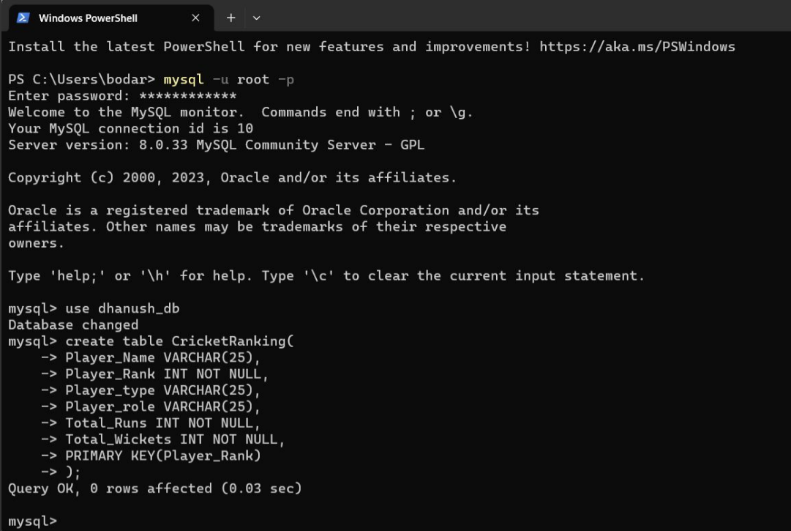

**Inserting values into database**

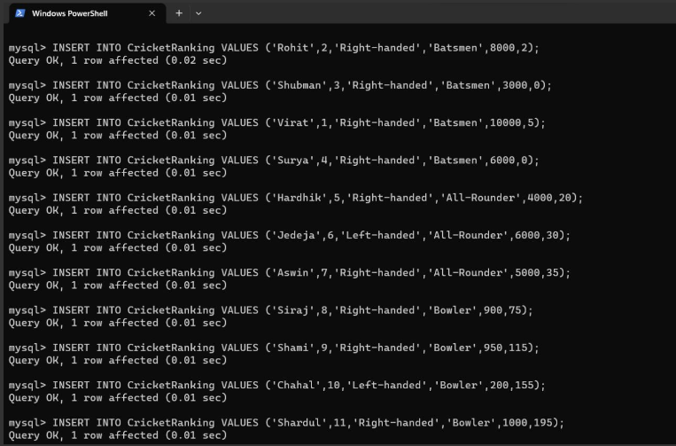

**Visualizing the Database**

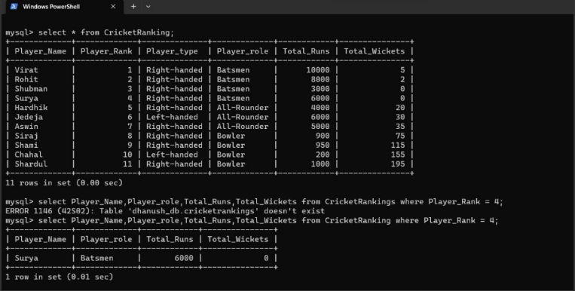

**Work-Bench Output:**

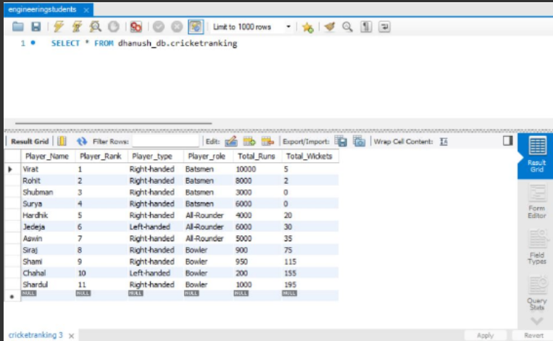

**Connecting the Database with Java JDBC:**

**import java.sql.Connection;**

**import java.sql.DriverManager;**

**import java.sql.ResultSet;**

**import java.sql.Statement;**

**public class main {**

**public static void main(String[] args) {**

**try {**

**Connection conn = DriverManager.getConnection("jdbc:mysql://localhost:3306/dhanush_db","root","Anuprasad_19");**

**Statement statement = conn.createStatement();**

**ResultSet resultSet = statement.executeQuery("select * from CricketRanking");**

**while (resultSet.next()) {**

**System.out.println(resultSet.getString("Player_Rank")+ " " +resultSet.getString("Player_Name"));**

**}**

**}**

**catch (Exception e) {**

**e.printStackTrace();**

**}**

**}**

**}**

**OUTPUT**

